**Project Planner Manual**

**Project Planner v1.5**

Installation 10

Updating Project Planner 10

Supported Unity versions 10

Shortcuts 11

Default 11

Change 11

Menu 12

Board Window 12

Task Window 12

Tree Window 12

Code Analyzer 12

Quick Task 12

Settings 12

Import Demo content 12

Manual 12

GitHub 12

Board Window 13

What is a board? 13

Window 13

Select 13

New 13

Rename 13

Delete 14

Group 15

New 15

Rename 15

Delete 15

Move 15

Duplicate 15

Copy 15

Paste 16

Paste as new 16

Paste values 16

Sort Tasks 16

Name 16

Created 16

Updated 16

Progress 16

Task Window 17

Window 17

Select 17

New 17

Delete 17

Move 18

Copy 18

Paste 18

Paste as new 18

Paste values 18

Duplicate 18

Sections 18

Name 18

Description 19

Tags 19

New 19

Select 19

Delete 19

Rename 19

Colors 19

New 19

Select 19

Delete 20

Change 20

Assigning Assets 20

Add 20

Select 20

Replace 20

Remove 20

Screenshots 20

Add 20

Delete 20

Rename 20

View in Unity 21

View in explorer 21

Subtasks 21

Navigating 21

New 21

Mark as completed 21

Hide completed 21

Locking 21

Lock task 21

Lock task and subtasks 21

Lock all task in group 22

Colors 22

Search by name and description 22

Search by tag 22

Tags popup window options 22

Search by color 22

Colors popup window options 23

Timestamps 23

Tree Window 24

Context Menu 24

Rename Board 24

Delete Board 24

New Group 25

Foldout 25

Dragging 25

Left 25

Right 25

Board Ordering 25

Code Analyzer Window 26

Scan 26

Scan words 26

Not implemented exception 27

Find 27

Make Task 27

Search 27

Foldout 27

Hide files 27

Quick Task Window 28

Select Board 28

Select Group 28

Name 28

Description 28

Subtasks 28

Add 29

Add and close 29

Settings window 30

Popup Windows 31

Options 31

Tags popup window 31

Undo 31

New 31

Select 31

Delete 31

Rename 32

Search 32

Colors popup window 33

Undo 33

New 33

Select 33

Delete 33

Change 33

Assets popup window 34

Undo 34

Add 34

Select 34

Replace 34

Remove 34

Demo Content 35

Folder Structure 36

How to move 36

Menu.cs 36

Data files 36

Temporary assets files 36

Permanent json file 36

Screenshot files 37

Manually Backup 37

Merging and Source Control 37

Language files 37

Language 38

Default language 38

Edit 38

New 38

Undo 39

Effect on your project 39

Editor 39

Build 39

Settings 40

Board Window 40

Allow multiple windows 40

Board name in window tab 40

Minimum height 40

Minimum width 40

Utility 40

Group 40

Drag threshold 40

Fixed width 41

Fixed height 41

Grid 41

Height 42

Hide empty when searching 42

Place new 43

Task 43

Description indicator 43

Drag threshold 43

Min height 43

Show description indicator 43

Task Window 44

Auto dock with board 44

Description fixed height 44

Description height 44

Foldout animation 44

Minimum height 44

Minimum width 44

Show timestamps 44

Utility 44

Tree Window 44

Group 44

Drag threshold 44

Hide empty when searching 45

Task 45

Description indicator 45

Drag threshold 45

Show description indicator 45

Coloring 45

Row Coloring 45

Same -> Color 45

Alternating -> Even 45

Alternating -> Odd 45

By Type -> Board 45

By Type -> Group 45

By Type -> Task 45

By Type -> Subtask 46

Row style 46

Board General 46

Default name 46

Default groups 46

Group General 46

Default name 46

Task General 46

Auto select new 46

Default name 46

Tags 46

Enabled 46

Confirm removal 46

Show by default 47

Colors 47

Enabled 47

Confirm removal 47

Icon type 47

Show by default 47

Assets 47

Enabled 47

Confirm removal 47

Show by default 47

Screenshots 48

Enabled 48

Auto view new 48

Background color 48

Confirm removal 48

Default name 48

Show by default 48

Utility window 48

Subtasks 48

Enabled 48

Show by default 48

Show individual progress 48

Show progress bar 49

Show progress in board window 49

Locking 49

Enabled 49

Show indicator 49

-Color 49

-Subtask color 50

Code analyzer 50

Double click to find 50

Foldout open by default 50

Find not implemented exception 50

Hide files 50

Scan words 50

Scan words are case sensitive 50

Selectable message 50

Show select file button 50

Show scan word with message 50

Use threads 50

Scan after compiling 51

Scan on window open 51

Include file name in search 51

Utility 51

Others 52

Adaptive mouse cursor 52

Hide UI when dragging 52

Language 52

Show window title icon 52

Support undo 52

Reset 53

Compatibility 54

Newtonsoft.Json.dll 54

# 

# Installation

Before installing Project Planner, make sure asset serialization mode is set to “Force Text”.

You can find the setting here *“Edit->Project Settings->Editor->Asset Serialization”*.

To install Project Planner you can either download the entire project from GitHub and copy the Project Planner root folder into your own Assets folder. You can also (recommended) download the .unitypackage file and import that into your unity project.

# Updating Project Planner

When updating, always make a backup of your Project Planner data in case your Unity project is not compatible with the new version. You should also close all Project Planner windows before importing the update.

If you need an older version of Project Planner that is not available on the Asset Store, you can write to me, and I will send it to you.

# Supported Unity versions

Unless Unity makes a significant change to the editor in a version, Project Planner should work on all Unity versions after version 2017.4.19.

# 

# Shortcuts

## Default

Ctrl+Alt+B

Open the board window.

Ctrl+Alt+T

Open the task window.

Ctrl+Alt+Q

Open the quick task window

## Change

If you are using Unity 2019 or later, you can ignore the instructions below and use Unity's shortcut manager instead.

If you want to change the shortcuts used by Project Planner you need to edit the MenuItem attributes in the Menu.cs file. You can read about how to locate the Menu.cs file under “Folder Structure”. If you are not sure how to use a MenuItem attribute I recommend reading Unity's documentation here: <https://docs.unity3d.com/ScriptReference/MenuItem.html>

# 

# Menu

You can find the Project Planner menu in the menu bar at the top under *Tools->Project Planner*.

## Board Window

Opens the board window.

## Task Window

Opens the task window.

## Tree Window

Opens the tree window.

## Code Analyzer

Opens the code analyzer window.

## Quick Task

Opens the quick task window.

## Settings

Opens the settings window.

## Import Demo content

Imports demo content.

## Manual

Opens the manual in your default pdf viewer.

## GitHub

Opens the Project Planner GitHub page.

# 

# Board Window

## What is a board?

A board is a collection of tasks that are organized into groups. A board is not meant to contain every task you ever make. A board should represent a period of time or a specific area of work.

## Window

In the board window, you can view and edit the contents of your boards.It is a good idea to dock the board window somewhere with a lot of space as it quickly gets filled up with groups.

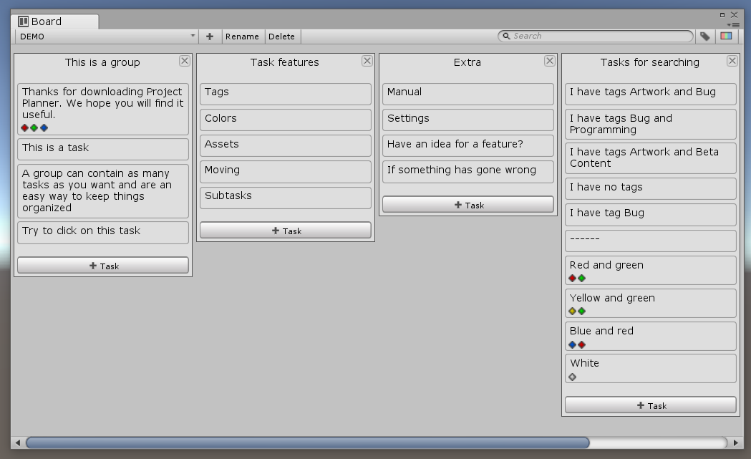

## Select

To select a board click on the button with the currently selected board's name in the board window toolbar. When you click a context menu appears with all the boards you can select.

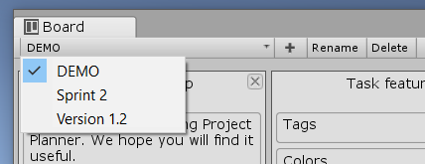

## New

To create a new board click on the  button in the board window toolbar.

## Rename

All board names must be unique. If you try to enter a name that is already taken a numeric prefix will be added.

With the board you want to rename selected, click on the “Rename” button in the board window toolbar. When you have clicked the rename button the select board button is replaced with a text field where you can edit the board's name. When you are done press the enter key or click outside the text field.

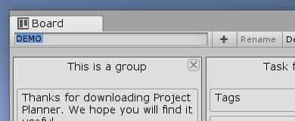

When you name a board, you can use “/” to create submenus in the select board menu.

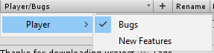

## Delete

With the board you want to delete selected, click on the “Delete” button in the board window toolbar. If a board contains a task that is locked the delete button is disabled.

# 

# Group

## New

To make a new group click on the “New Group” button in the board window toolbar. You can choose where to place new groups in the settings. By default, they are placed last.

## Rename

All group names must be unique. If you try to enter a name that is already taken a numeric prefix will be added.

To rename a group double click or right click on the groups name and select “Rename” in the context menu. The name is replaced with a text field where you can edit the group name. When you are done, press the enter key or click outside the text field.

## Delete

To delete a group click on the  button in the top right corner of the group you want to delete or right click on the group name and select “Delete” in the context menu.

## Move

To move a group hold click on its name and drag it to where you want it. The group that is being moved around has an extra margin at the top. You can also move a group left or right by right-clicking on its name and selecting “Move left” or “Move right.”

If you want to move a group to another board right-click on its name and select “Move to board” and then the name of the board you want to move to.

## Duplicate

To duplicate a group right click on its name and select “Duplicate” in the context menu.

## Copy

To copy a group right click on its name and select “Copy” in the context menu.

## 

## Paste

When pasting a group, you have two options. You can make a new copy or replace an existing group with the copied group.

### Paste as new

* Right click on a group name and select “Paste as new”. The new group will be placed after the one you right clicked on.
* Right click on the “New Group” button in the board window toolbar and select “Paste as new”. The new group will be placed in the same way as if you had used the new group button normally.

### Paste values

To replace the values of a group with the copied group ’s values, right click on a group and select “Paste values” in the context menu.

## Sort Tasks

To sort tasks in a group right click on the group name, select “Sort” and then how you want to sort the tasks. When sorting it does not matter if a task is locked or not.

### Name

* ASC: Alphabetical order.
* DESC: Reverse alphabetical order.

### Created

* ASC: Newest first.
* DESC: Oldest first

### Updated

* ASC: Most recently updated first.
* DESC: Least recently updated first.

### Progress

* ASC: Most progress first.
* DESC: Least progress first.

# 

# Task Window

## Window

In the task window, you can view and edit a task. The task window takes up a lot of space vertically. A good place to dock the task window is with the inspector.

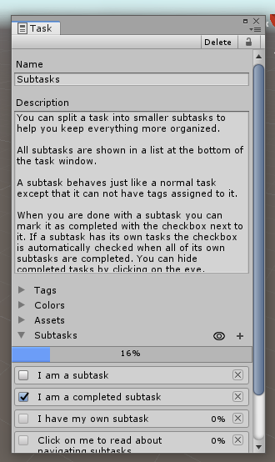

## Select

You select a task by clicking on it or by right-clicking and selecting “Edit” in the context menu. If the task window is closed when you select a task, it will open. If the task window is already open, it will be focused.

## New

To make a new task click on the 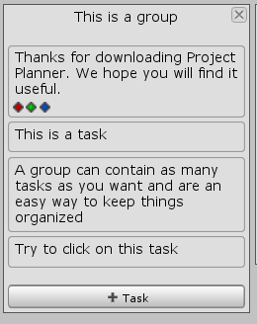 button at the bottom of the group you want to add the task to or right click on a group name and select “New task” in the context menu.

## Delete

To delete a task click on the “Delete” button in the task window toolbar or right click on a task and select “Delete” in the context menu.

If you delete a subtask using the delete button in the task window its parent task will be selected.

## Move

To move a task hold click on its name and drag it to where you want it. You can also right click and select “Move up” or “Move down” in the context menu. The task that is being moved around has an extra margin to the sides.

If you want to move a task to a group in another board right-click on it and select “Move to group” then the name of a board and then the name of the group you want to move to.

## Copy

To copy a task right click on it and select “Copy” in the context menu.

## Paste

When pasting a task, you have two options. You can make a new copy or replace an existing task with the copied task.

### Paste as new

* Right click on a task and select “Paste as new”. The new task will be placed after the one you right clicked on.
* Right click on a group name and select “Paste task”. The new task is placed first.
* Right click on the new subtask button and select “Paste task”. The new subtask is placed first.

### Paste values

To replace the values of a task with the copied task’s values, right click on a task and select “Paste values” in the context menu.

## Duplicate

To duplicate a task right click on it and select “Duplicate” in the context menu.

## Sections

Below the description, the task window is split into sections. You can toggle the visibility of a section by clicking on the arrow to the left of its name. If you don't use a feature you can disable it in the settings and the section for that feature will not appear anymore.

## Name

The task name is used in the board window to show a task. Try to keep the name short and precise, so it does not take up to much space in the board window.

If the task does not have a name the text “NO NAME” will be used instead.

## Description

The description is where you write down in detail what needs to be done to complete the task. If you feel like the description is getting too big, consider splitting the task up into smaller subtask.

If a task has a description, an indicator is added to the end of the task name. By default “...” is added. You can disable this feature or edit the indicator text in the settings.

## Tags

### New

To add a new tag you first write the name of your new tag in the text field below the list of tags, you then click on the add button to the right. You can not have more than one tag with the same name. Tags are not case sensitive.



### Select

You can select a tag by clicking on the toggle button to the left of it . A tag is selected when they are a checkmark in the button.

### Delete

To delete a tag click on the button to the right of the tag you want to delete. Tags are shared so if you delete a tag it will affect every task with that tag.

### Rename

To rename a tag just change the content of the text field with the tags name in it.

## Colors

Colors are displayed with the task name in the board window and in the list of subtasks.

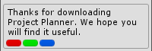

### New

You can add a new color by clicking on the white area at the bottom of the list of colors. After clicking, a color picker appears where you can select the color you want. When you are done selecting a color, click on the add button to the right.



### Select

You can select a color by clicking on the toggle button to the left of it. A color is selected when they are a checkmark in the button.

### Delete

To delete a color click on the button to the right of the color you want to delete. Colors are shared so if you delete a color it will affect every task with that color.

### Change

To change a color click on it and select the new color in the color picker that appeared.

## Assigning Assets

### Add

You can add an asset by clicking on the small circle  to the left of the empty object field where it says “None (Object)”. You can add the same asset multiple times.

### Select

To select an asset click on it. When you click on an asset it will be highlighted and selected in the Project view.

### Replace

You can replace an asset by clicking on the circle to the left of it and select a new asset.

### Remove

To remove an asset click on the button to the right of the asset you want to remove. You can also click on it and press the delete key.

## Screenshots

### Add

You can add a screenshot to a task by clicking on the icon to the right of where it says screenshots. In order to add a new screenshot, the game view must be selected. Project Planner tries to select the game view for you automatically.

### Delete

To delete a screenshot click on the button to the right of the screenshot you want to remove. You can also delete a screenshot by first clicking on the “View” button and then the “Delete” toolbar button in the screenshot window.

### Rename

To rename a screenshot just change the content of the text field with the screenshot name in it.

You can also rename a screenshot by first clicking on the “View” button and using the text field to the left in the screenshot window toolbar.

### View in Unity

You can view a screenshot by clicking on the “View” button to the right of the screenshot. A new window will appear with your screenshot.

### View in explorer

You can also view the screenshot using your own image viewing software by first clicking on the “View” button and then the “Open in explorer” toolbar button in the screenshot window.

## Subtasks

The way a subtask behaves and how you interact with it is almost the same as a normal task. The differences are described below.

### Navigating

When viewing a subtask two extra buttons are available in the toolbar to the left. The first button is named “Back”. The back button takes you back to the parent of the task you are viewing. The second button is named “Go to”. The go to button shows you a list of all task leading back to the first task. This is useful if you have a lot of nested tasks.

### New

You can add a subtask to a task by clicking on the icon to the right of where it says subtasks.

### Mark as completed

When you are done with a subtask you can mark it as completed by clicking on the button to the left of the subtask. If the subtask also has subtasks the button cannot be toggled manually.

### Hide completed

You can hide completed subtasks by clicking on the eyeabove the subtasks. The eye is green when completed subtasks are hidden.

## Locking

When a task is locked, you cannot edit, delete or move it, and all empty fields will be hidden. You can also not delete any object that has a locked task in it. Example: If you have a board with a locked task in it, the board cannot be deleted.

### Lock task

* Click on the  button in the top right corner of the task window.
* Right click on a task and select “Lock/Lock” or “Lock/Unlock” in the context menu.

### Lock task and subtasks

This operation is recursive so if a subtask has its own subtasks, they will also be affected.

* Right click on the  button in the top right corner of the task window and select “Lock including subtasks” or “Unlock including subtasks”.
* Right click on a task and select “Lock/Lock including subtasks” or “Lock/Unlock including subtasks” in the context menu.

### Lock all task in group

* Right click on the group name and select “Lock/Lock tasks” or “Lock/Unlock tasks” in the context menu.

### Colors

When a task is locked, a colored line is shown to the left of the task name. You can disable this feature or edit the colors used in the settings.

A dark line means the task itself is locked.



A grey line means the task contains a subtask that is locked.



## Search by name and description

Too filter what task to show by their name and description write your search query in the text field with the small magnifying glass in the right side of the toolbar. Searching is not case sensitive.

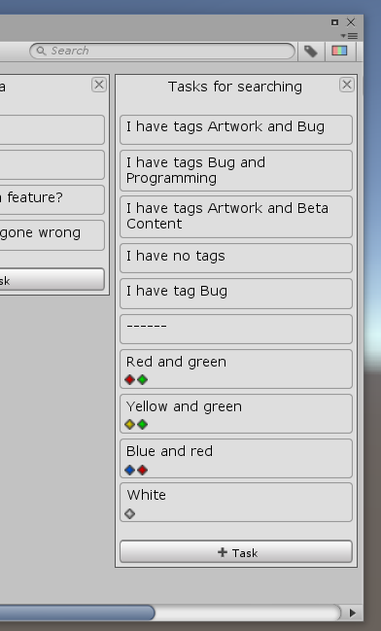

When searching you can specify if you want to search by name or description only by writing "n:" (only name), “d:” (only description) followed by your search query.

## Search by tag

To filter what task to show by their tags click on the button on it in the right side of the toolbar. A popup window appears where you can select your tags.

### Tags popup window options

Reset: marks all tags as not selected.

Task has all selected: if true a task has to include all selected, if false it just has to include one.

## Search by color

To filter what task to show by their color click on the button on it in the right side of the toolbar. A popup window appears where you can select your colors.

### Colors popup window options

Reset: marks all colors as not selected.

Task has all selected: if true a task has to include all selected, if false it just has to include one.

## Timestamps

Timestamps show when a task was created and when it was last updated. The timestamps are located at the bottom of the task window. By default timestamps are hidden, this can be changed in the settings.

# 

# Tree Window

The tree window is an alternative to the board window. The two main differences between the board and tree window are that all boards and subtasks a shown and that everything is flowing downwards in a tree structure.

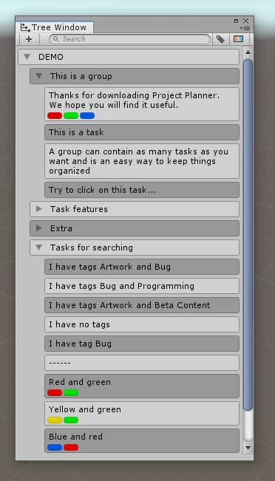

The way you interact with boards, groups, and tasks are a lot like you do in the board window. If you want to learn how to do something you can find the answer under the Board Window section of the manual. The differences between the board and tree window are described below.

## Context Menu

Most of what you can do in the tree window is done using the context menu. You can open the context menu by right-clicking on a board, group, or task.

## Rename Board

To rename a board double click or right click on the boards name and select “Rename” in the context menu. The name is replaced with a text field where you can edit the board name. When you are done, press the enter key or click outside the text field.

## Delete Board

To delete a board right click on the board name and select “Delete” in the context menu.

## New Group

To make a new group right click on a board name and select “New group” in the context menu.

## Foldout

All rows that have other rows under them has an arrow to the right that toggles the visibility of the sub rows. When searching all relevant rows are shown no matter the toggle state.

## Dragging

When dragging groups and tasks around it makes a difference what side of a row the cursor is over.

### Left

The row hides its sub rows. If you are dragging a task it is placed together with the task the cursor is over.

### Right

The row shows its sub rows. If you are dragging a task it is placed as a subtask of the task the cursor is over.

## Board Ordering

The boards are ordered in alphabetical order and cannot move moved.

# 

# Code Analyzer Window

The code analyzer can search through all your scripts and find comments that starts with specific words like “TODO”. It can also find not implemented exceptions and list them in the code analyzer window.

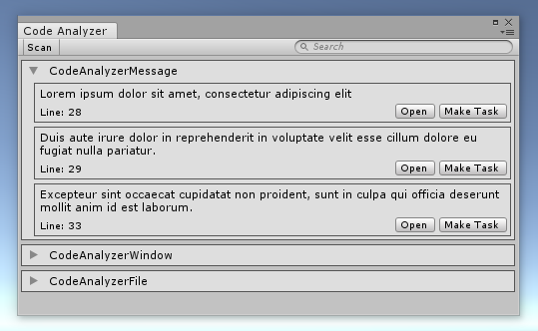

## Scan

The content of the window is not updated in real-time and need to scan your scripts in order to reflect the correct information. To manually run a scan click the “Scan” button in the toolbar. You can also configure the code analyzer to automatically run when compiling scripts. This is on by default.

### Scan words

When scanning the code analyzer looks for comments starting with a scan word. You can change the scan words in the settings. The word has to be part of a // comment and in the beginning.

By default, scan words are not case sensitive. This can be changed in the settings.

Here is an example of a comment that will be found.

|  |
| --- |
| 24. //TODO Make into a property later 25. public Rect rectAbsolute; |



### 

### Not implemented exception

When scanning, the code analyzer can also find not implemented exceptions. This can be changed in the settings but is on by default. The code analyzer is more flexible when looking for exceptions then with scan word. It does not have to be on a line by itself. As long as “new NotImplementedException” is part of a line it will be found.

Here is an example of a not implemented exception that will be found.

|  |
| --- |
| 32. public void KillThePlayer() 33. { 34. throw new NotImplementedException(); 35. } |



## Find

You can find a comment or exception by clicking on the “Find” button or by double-clicking anywhere in the box. When you use the find feature the code analyzer will open the file the result is from and jump to the line it is on.

## Make Task

You can make a result into a task by clicking on the “Make Task” button. After clicking you have to select what group you want to place the task in. You can add the same result multiple times.

The task ́s name will be the comment in your code. Its description is the name of the file and the line it was on. The task will also have the script assigned as an asset.

## Search

You can filter what results to see by using the search field in the toolbar.

## Foldout

You can hide the results of a file by clicking on the arrow in the top left corner of the box belonging to that file. If you want to show the content again click the arrow. By default, the foldout is set to show.

## Hide files

You can hide files with a specific name in the settings under “Settings->Code analyzer->Hide files”

# Quick Task Window

The quick task window is designed to do two things. The first is to make it easier to create multiple tasks right after each other without having to use the mouse. The second is to add a new task without having to leave what you are doing to find the board and task window. When you open the window, it will always center itself in the middle of the screen.

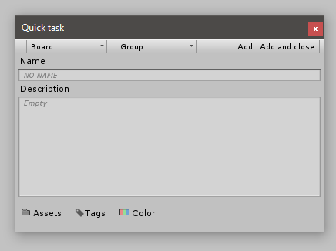

## Select Board

Click on the first button with a small arrow in the toolbar to the left. When you click a context menu appears with all the boards you can select.

## Select Group

After selecting a board, you have to pick a group to place the task in. Click on the second button with a small arrow in the toolbar to the left. When you click a context menu appears with all the groups from the selected board.

## Name

The name field ignores the default task name setting. The name field is automatically selected when you use the shortcut to open the window and after you add a task.

## Description

The description field ignores the fixed description height setting. You can select the description field by pressing the tab key while the name field is selected.

## 

## Subtasks

You can not make subtasks in the quick task window. If you want to add subtasks you have to use the task window.

## Add

When you are ready to add your task click on the “Add” button to the right in the toolbar, you can also use the shortcut “Ctrl+Enter”. After you add a task, the quick task window will reset and select the name field, so you are ready to add a new task again. If you want to close the window after adding a task, click the “Add and close” button.

## Add and close

The “Add and close” button to the right in the toolbar behaves in the same way as the “Add” button except that it closes the window instead of resetting it. You can use the shortcut “Ctrl+Alt+Enter” to activate it.

# 

# Settings window

Project Planner has two settings windows you can use. The windows contain the same settings and are synchronized with each other, so the only difference is where they are located.

The first is Project Planners own window and can be found by going to *Tools->Project Planner->Settings*. You can also access the settings from the window menus.

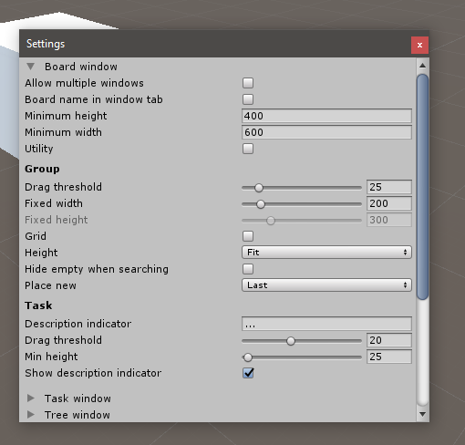

The second is Unity ́s build in preferences window and can be found by going to *Edit->Preferences->Project Planner*.

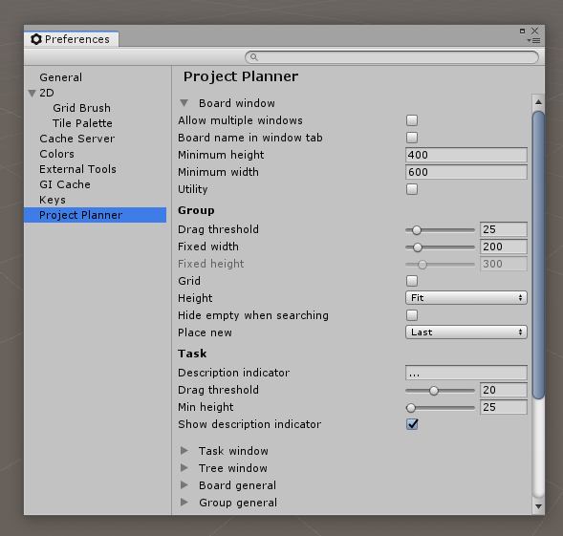

You can read more about what the settings do under “Settings”

# Popup Windows

## Options

Sometimes when you open a popup window you have some extra options to choose from. If extra options are available the button appears on the right side of the toolbar. When you click the button a menu appears under the toolbar with the options. You can hide the menu again by clicking on the button.

## Tags popup window

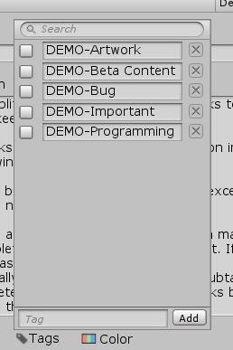

### Undo

When you close the popup window all undo operations inside the window is merged into one single undo action.

### New

To add a new tag you first write the name of your new tag in the text field at the bottom of the window, you then click on the add button to the right. You can not have more than one tag with the same name. Tags are not case sensitive.



### Select

You can select a tag by clicking on the toggle button to the left of it . A tag is selected when they are a checkmark in the button.

### Delete

To delete a tag click on the button to the right of the tag you want to delete. Tags are shared so if you delete a tag it will affect every task with that tag.

### Rename

To rename a tag just change the content of the text field with the tags name in it.

### Search

You can filter what tags to show in the window by writing your search query in the text field at the top of the window.



## 

## Colors popup window

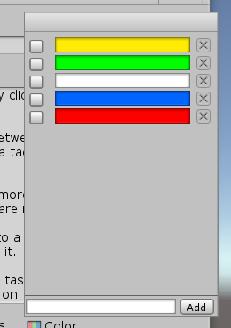

### Undo

When you close the popup window all undo operations inside the window is merged into one single undo action.

### New

You can add a new color by clicking on the white area at the bottom of the window. After clicking, a color picker appears where you can select the color you want. When you are done selecting a color, click on the add button to the right.



### Select

You can select a color by clicking on the toggle button to the left of it. A color is selected when they are a checkmark in the button.

### Delete

To delete a color click on the button to the right of the color you want to delete. Colors are shared so if you delete a color it will affect every task with that color.

### Change

To change a color click on it and select the new color in the color picker that appeared.

## 

## Assets popup window

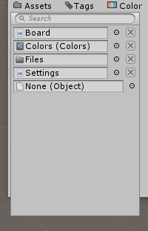

### Undo

The asset popup window does not support Unity’s undo system when adding and removing assets. When you close the window everything you have done will be saved as a single undo action.

### Add

You can add an asset by clicking on the small circle  to the left of the empty object field where it says “None (Object)”. You can add the same asset multiple times.

### Select

To select an asset click on it. When you click on an asset it will be highlighted and selected in the Project view.

### Replace

You can replace an asset by clicking on the circle to the left of it and select a new asset.

### Remove

To remove an asset click on the button to the right of the asset you want to remove. You can also click on it and press the delete key.

**Search**

You can filter what assets to show in the window by writing your search query in the text field at the top of the window. When searching you can show a specific type of asset by writing "t:" followed by the type of assets you want.



# 

# Demo Content

Project Planner comes with demo content that is designed to guide you through the essential features and how to use them. If you are new to Project Planner and the kind of person that learns best by example I recommend that you have a look at the demo content.

To import the demo content click on *Tools->Project Planner->Import | Export->Demo Content*. The import process will not override any existing data. The demo content adds the tags “DEMO-Artwork”, “DEMO-Beta" Content”, “DEMO-Bug”, “DEMO-Programming”, “DEMO-Important” and the colors red, blue, green, yellow and white. A new board named “DEMO” is added. If everything has been imported correctly, the demo board should look like the image below.

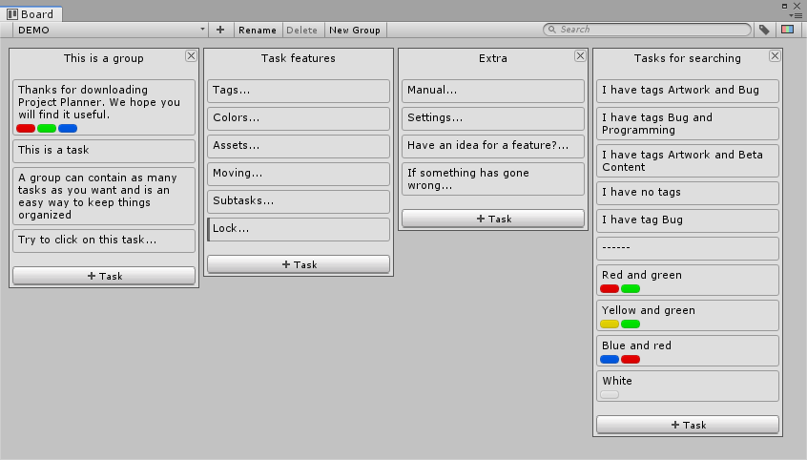

All demo content is named with the prefix “DEMO” to make it easy to locate and delete again. If you import the demo content more then once, the demo tasks will share the same tags and colors, but each board will be named DEMO with a numeric postfix.

# Folder Structure

When you import Project Planner a new folder named “Project Planner” is created in your assets folder.

## How to move

You can move the Project Planner folder to wherever you want inside the assets folder. When you move the folder, you have to be sure that you move the folder with the project_planner_locator file in it and that you keep the same folder structure inside the Project Planner folder.

## Menu.cs

The menu.cs file is located at "Project Planner/Editor/Menu.cs". The reason Menu.cs is outside the DLL file is so you can change the shortcuts used by Project Planner. You can read more about how to change the shortcuts under “Shortcuts”

## Data files

### Temporary assets files

While working in the editor, all data is stored as ScriptableObjects (.asset files) inside the “Project Planner\Editor\Data” folder. This is because it is fast to read and write to assets files, but the data here is only temporary and is frequently overwritten or cleared.

### Permanent json file

When Unity performs a save event like saving a scene, the project, or closing, the data from the .asset files are combined and saved as .json in a folder called “Project Planner” in your project root folder. The .json file is used to store data that needs to persist between Unity sessions.

The .json file does not follow the standard JSON format, so if you want to read the content of the file, there are a few things you need to know. Each line contains an ID prefix followed by one of the .asset files as standard JSON. Below is a list of IDs and their corresponding .asset files.

00 - Boards

01 - Groups

02 - Tasks

03 - Tags

04 - Colors

I recommend <https://jsonformatter.curiousconcept.com> if you want to format the JSON to make it easier to read.

### Screenshot files

All task screenshots are saved in “{your project root folder}/Project Planner/Screenshots/{task id}/”. While working in unity two extra folders called “tmp” and “copy” will sometimes appear. The two extra folders will disappear again when you close Unity.

### Manually Backup

If you want to manually backup your data you have to make a copy of the .json file, not the .asset files. To make sure everything has been saved fully it is a good idea to save your project manually by selecting “File->Save Project” in the top Unity menu.

If you want to restore a backup manually, close Unity, then replace the .json file and reopen Unity. If you replace the file while Unity is open, it will be overwritten by the .asset files when a save event triggers.

If any of your tasks has screenshots on them you also need to make a copy of the screenshots folder. The folder is in the same location as the .json file.

### Merging and Source Control

If you are using source control like Git and want to commit your changes, you first have to trigger a save event. You can do this by saving a scene, the entire project, or closing Unity. When you have triggered a save event you can commit the .json file in the “Project Planner” folder in your project root folder. It does not matter if you commit the .asset files in “Assets\Project Planner\Editor\Data” folder.

When merging two .json files, it is always recommended to use everything from one file only to avoid missing references. If you need to or by mistake merge two .json files and breaks references, Project Planner will be able to recover most of the data most of the time, but this is not something you should rely on. A more effortless merging system will be added in a later update.

## Language files

The language files used by Project Planner are saved as .asset files inside the “Project Planner\Editor\Language” folder. If you want to add your own language file its has to be placed inside this folder.

# 

# Language

## Default language

English is the default language. It is not possible to remove English as a language. If Project Planner is not able to find the English language file, it will auto-generate a new one.

## Edit

To edit a language file, you first have to select it in the Project window. When selected a list with all the words and sentences used by Project Planner in alphabetical order is shown in the inspector window. The Inspector window has a label and a text field for every word/sentence. The label is the original text in English, and the text field is the text used by Project Planner. You can search for translations using the search text field in the top of the inspector window.

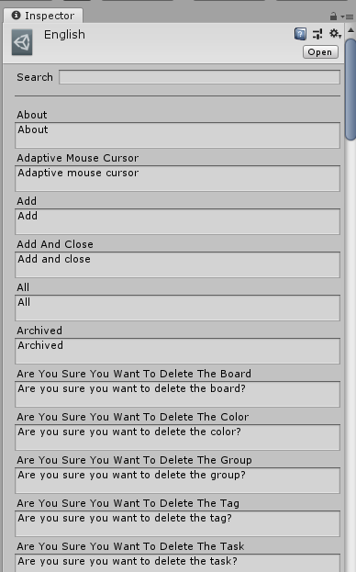

## New

You can add your own language to Project Planner by right-clicking on the language folder and then Create->Project Planner->Language in the context menu. You can read more about how to find the language folder under “Folder Structure”.

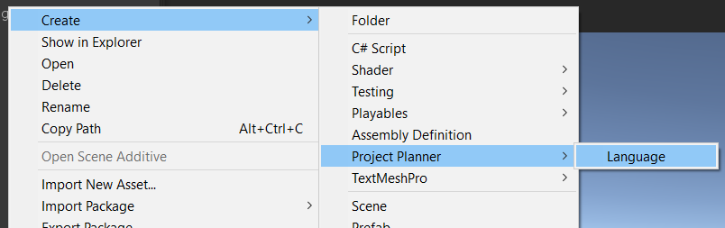

# 

# Undo

Project Planner supports Unity’s undo system so every action you do in the board and task window can be undone again. When you close both the board and task window all undo operations related to Project Planner is cleared. You are not able to undo changes made in the settings window.

# Effect on your project

## Editor

A lot of the data used by Project Planner is not written to the disk until Unity triggers a save event like saving the project, a scene, or when closing. I do this to avoid freezing the editor while you are working, but it also means that if you have been working for a long time and manipulated a lot of data, it may take a few seconds longer to perform some of the above mansion actions than usual.

Project Planner does not affect your compile time when you make changes to your code because it comes precompiled.

## Build

Project Planner will not affect your game performance or size because Unity ignores 99% of all Project Planner files when compiling your game.

# 

# Settings

## Board Window

#### Allow multiple windows

*Default: false*

If true, you can have multiple board windows open at the same time; else the existing window will be focused when trying to open a new.

#### Board name in window tab

*Default: false*

If true, the board window tab will display the name the selected board.

#### Minimum height

*Default: 400*

Minimum height the board window can be.

#### Minimum width

*Default: 600*

Minimum width the board window can be.

#### Utility

*Default: false*

Show the board window as a utility window. A utility window cannot dock with other windows or be maximized.

### Group

#### Drag threshold

*Default: 25*

The distance in pixels you have to move the mouse when drag moving a group before it registers.

#### 

#### Fixed width

*Default: 200*

The width of a group in pixels.

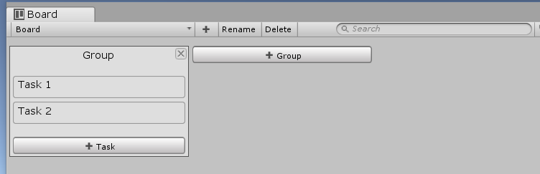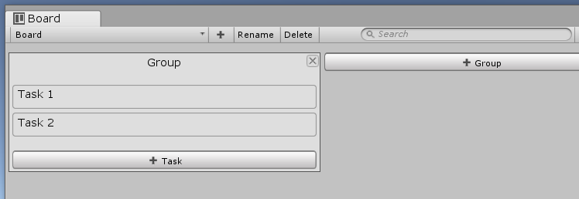

#### Fixed height

*Default: 300*

The height of a group in pixels when “Fixed” is selected in the height setting.

#### Grid

*Default: false*

Display groups in a grid instead of a horizontal line.

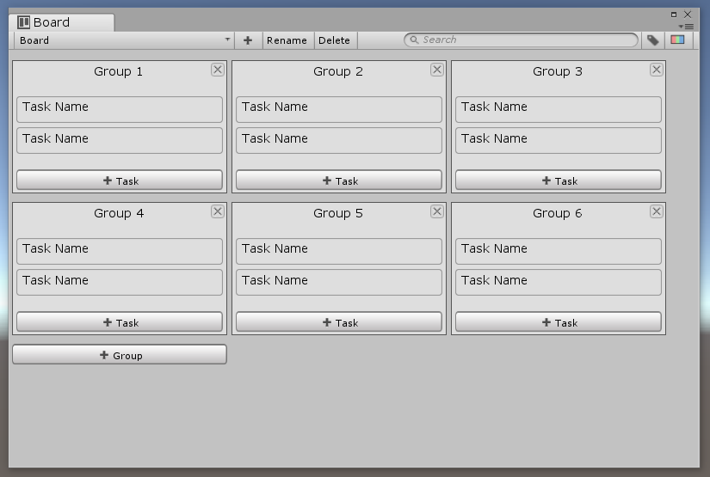

#### 

#### Height

*Default: Fit*

How the height of a group is calculated.

**Fit**: Has the exact height needed to show the content of the group.

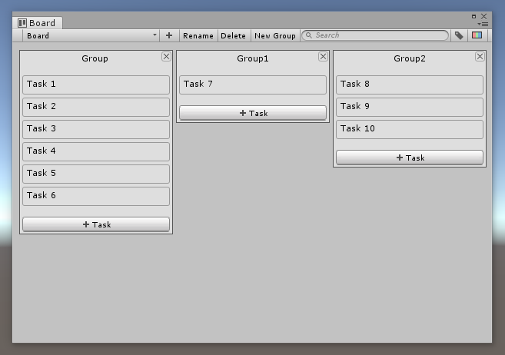

**Fixed**: Has the same height no matter the content of the group.

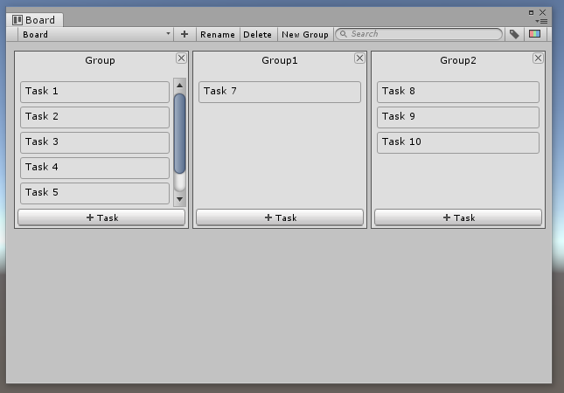

**Fill**: Fills the entire height of the window no matter the content of the group.

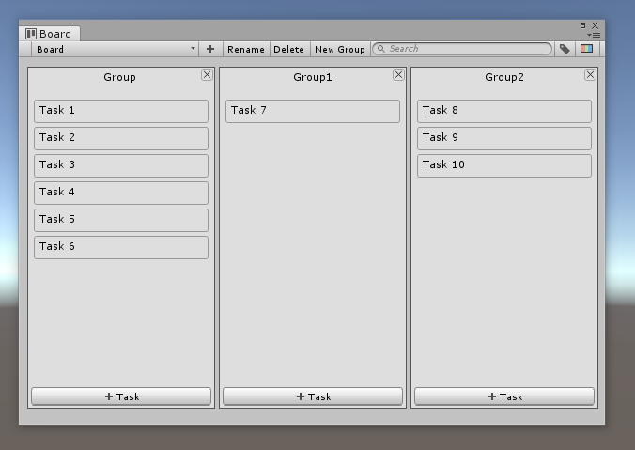

#### Hide empty when searching

*Default: false*

When searching hide groups that do not have any task shown in them.

#### Place new

*Default: Last*

Where to insert a new group.

### Task

#### Description indicator

*Default: ...*

What is added to a task name of the task has a description.

#### Drag threshold

*Default: 20*

The distance in pixels you have to move the mouse when drag moving a task before it registers.

#### Min height

*Default: 25*

The minimum height in pixels a task can have.

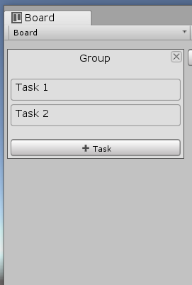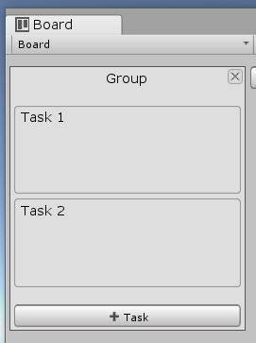

#### Show description indicator

*Default: true*

Add an indicator to a task name if the task has a description.

## 

## Task Window

#### Auto dock with board

*Default: false*

The task window tries to place itself in the same location as the board window when it opens.

#### Description fixed height

*Default: true*

Does the task description have a minimum height? If false the text field will try to fit the content.

#### Description height

*Default: 15*

Is only shown if “Fixed description height” is true. The minimum height a tasks description field can be.

#### Foldout animation

*Default: true*

If true, apply a smooth animation when toggling sections in the task window.

#### Minimum height

*Default: 400*

Minimum height the task window can be.

#### Minimum width

*Default: 300*

Minimum width the task window can be.

#### Show timestamps

*Default: false*

Show when the task was created and the last time it was updated.

#### Utility

*Default: false*

Show the task window as a utility window. A utility window cannot dock with other windows or be maximized.

## Tree Window

### Group

#### Drag threshold

*Default: 25*

The distance in pixels you have to move the mouse when drag moving a group before it registers.

#### Hide empty when searching

*Default: false*

When searching hide groups that do not have any task shown in them.

### Task

#### Description indicator

*Default: ...*

What is added to a task name of the task has a description.

#### Drag threshold

*Default: 20*

The distance in pixels you have to move the mouse when drag moving a task before it registers.

#### Show description indicator

*Default: true*

Add an indicator to a task name if the task has a description.

### Coloring

#### Row Coloring

*Default: By Type*

How to apply color to rows in the tree window.

#### Same -> Color

*Default: FFFFFF*

The color of all rows.

#### Alternating -> Even

*Default: FFFFFF*

The color of all the even rows.

#### Alternating -> Odd

*Default: 808080*

The color of all the odd rows.

#### By Type -> Board

*Default: FFFFFF*

The color of a board.

#### By Type -> Group

*Default: 808080*

The color of a group.

#### By Type -> Task

*Default: 333333*

The color of a task.

#### By Type -> Subtask

*Default: 333333*

The color of a subtask.

#### Row style

*Default: Box 1*

The image a row use for its background.

## Board General

#### Default name

*Default: Board*

The default name a board have when it is created.

#### Default groups

*Default: Planned, In Progress, Testing, Completed.*

List of groups a board has when it is created.

## Group General

#### Default name

*Default: Group*

The default name a group have when it is created.

## Task General

#### Auto select new

*Default: true*

Automatically select task and open the task window when a new task is created..

#### Default name

*Default: Task*

The default name a task have when it is created.

## Tags

#### Enabled

*Default: true*

If false the task tag feature will not be available.

#### Confirm removal

*Default: false*

When you try to remove a tag, a dialog appears asking if you are sure.

#### Show by default

*Default: false*

When a new task is created, the tags section is visible.

## Colors

#### Enabled

*Default: true*

If false the task color feature will not be available.

#### Confirm removal

*Default: false*

When you try to remove a color, a dialog appears asking if you are sure.

#### Icon type

*Default: Box*

The type of icon used to show task colors with.

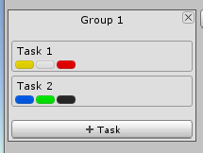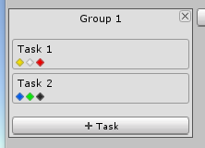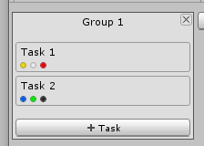

#### Show by default

*Default: false*

When a new task is created, the colors section is visible.

## Assets

#### Enabled

*Default: true*

If false the assigning assets to tasks feature will not be available.

#### Confirm removal

*Default: false*

When you try to remove an assigned asset, a dialog appears asking if you are sure.

#### Show by default

*Default: false*

When a new task is created, the assets section is visible.

## Screenshots

#### Enabled

*Default: true*

If false the screenshots feature will not be available.

#### Auto view new

*Default: false*

If true the screenshot window will appear when a new screenshot is added. This is the same as clicking the view button.

#### Background color

*Default: 000000*

The background color of the screenshot window.

#### Confirm removal

*Default: false*

When you try to remove a screenshot, a dialog appears asking if you are sure.

#### Default name

*Default: “Screenshot”*

The default a new screenshot gets when added.

#### Show by default

*Default: false*

When a new task is created, the screenshots section is visible.

#### Utility window

*Default: false*

Show the screenshot window as a utility window. A utility window cannot dock with other windows or be maximized.

## Subtasks

#### Enabled

*Default: true*

If false the subtask feature will not be available.

#### Show by default

*Default: true*

When a new task is created, the subtasks section is visible.

#### Show individual progress

*Default: true*

If a subtask also has its own subtasks show their progress next to the subtask name.

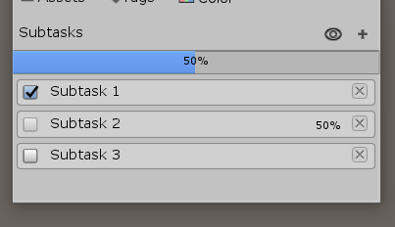

#### Show progress bar

*Default: true*

Show a progress bar above all the subtasks.

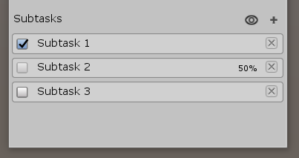

#### Show progress in board window

*Default: true*

Show the total subtasks progress under the task name in the board window. If a task does not have any subtasks this setting will be ignored.

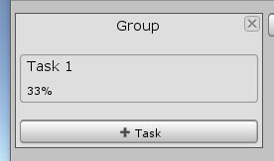

## Locking

#### Enabled

*Default: true*

If false the locking feature will not be available.

#### Show indicator

*Default: true*

Show a line to the left of a task if it is locked or have a locked subtask.

#### -Color

*Default: 0, 0, 0, 128*

The lock line color if the task itself is locked.

#### -Subtask color

*Default: 102, 102, 102, 128*

The lock line color if the task has a subtask that is locked.

## Code analyzer

#### Double click to find

*Default: true*

Double-clicking on a result has the same effect as clicking the find button.

#### Foldout open by default

*Default: true*

After scanning all file foldouts are set to show.

#### Find not implemented exception

*Default: true*

Scan for not implemented exception.

#### Hide files

*Default: Empty*

The code analyzer will ignore any file whose name is on the list. The names are not case sensitive.

#### Scan words

*Default: “TODO”*

List of words to use when scanning scripts.

#### Scan words are case sensitive

*Default: false*

If true scan words are case sensitive.

#### Selectable message

*Default: true*

The text in a result box can be selected using the mouse.

#### Show select file button

*Default: false*

Show a button that when clicked selects the file a result is from in the project view.

#### Show scan word with message

*Default: false*

Add the scan word as a prefix to a result.

#### Use threads

*Default: true*

Use threads when scanning scripts.

#### Scan after compiling

*Default: true*

Automatically start a scan after Unity is done compiling scripts.

#### Scan on window open

*Default: true*

Automatically start a scan when the window is first opened.

#### Include file name in search

*Default: true*

Use the file name as part of result searching.

#### Utility

*Default: false*

Show the code analyzer window as a utility window. A utility window cannot dock with other windows or be maximized.

## 

## Others

#### Adaptive mouse cursor

*Default: true*

Change the cursor to a hand icon when it is over something that can be clicked on.

#### Hide UI when dragging

*Default: true*

Hide some UI elements when dragging groups or tasks.

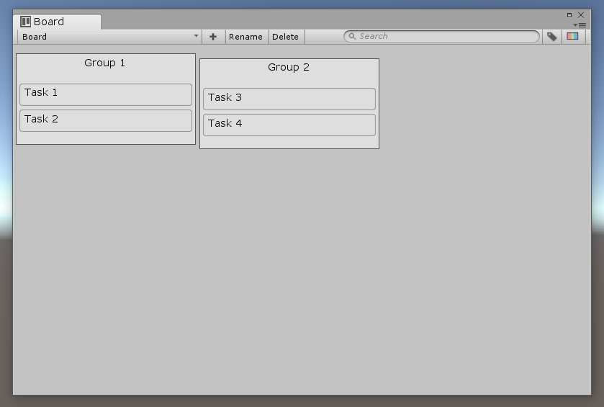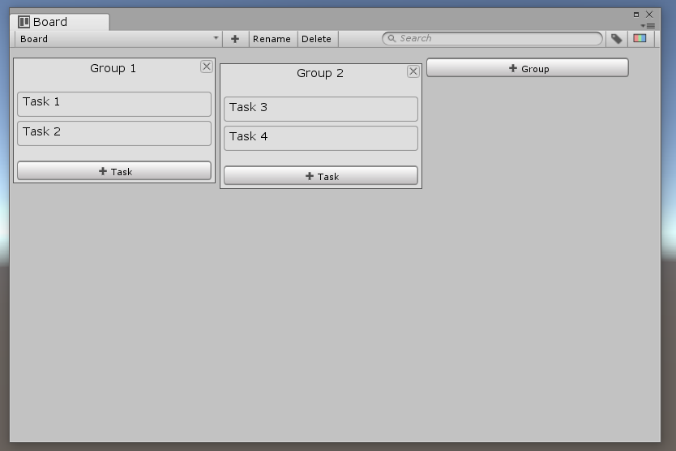

#### Language

*Default: English*

The language used by Project Planner.

#### Show window title icon

*Default: true*

Show an icon next to the name of the board and task window.

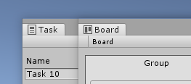

#### Support undo

*Default: true*

Integrate Unity’s undo system with Project Planner.

## 

## Reset

You can reset all settings to their default values by clicking on the reset button at the bottom of the settings window.

# Compatibility

## Newtonsoft.Json.dll

When using other packages you may sometimes get an error saying that you have more than one Newtonsoft.Json.dll and are unable to decide which one to use. You can fix it by clicking on Project Planners Newtonsoft.Json.dll and turn editor off under “Include Platforms” in the inspector like in the image below.

